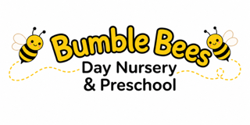

Our Early Years Curriculum
The Vision
At Bumble Bees Day Nursery, we want every child to develop into a confident, curious, capable and caring learner.
Our curriculum is designed to give children the knowledge, skills, vocabulary, experiences and attitudes they need to thrive both during their time at Bumble Bees and as they move on to the next stage of their education.
We recognise that every child is unique. We therefore provide an ambitious and inclusive curriculum that builds from each child's individual starting point, interests, experiences and needs.
Children learn through a balance of play, exploration, adult-led teaching, child-initiated learning, routines, real-life experiences and meaningful interactions with knowledgeable adults.
Our curriculum is underpinned by the 7 areas of learning and development in the EYFS, with particular emphasis on outdoor play, developing strong communication and language, secure relationships, physical development and independence.

Our Curriculum Intent
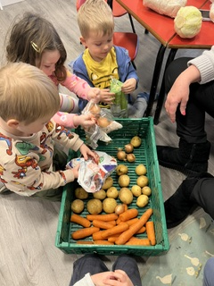
Communication - Children who can:
listen and understand | express their needs, ideas and feelings
develop a rich and varied vocabulary | engage in conversations
confidently communicate with adults and other children | enjoy and understand stories, rhymes and songs.

Personal, Social and Emotional Development - Children who:
feel safe, secure and valued | develop positive relationships
understand and express emotions | understand and express emotions
develop resilience | become increasingly independent
show kindness and respect | develop confidence and self-esteem.
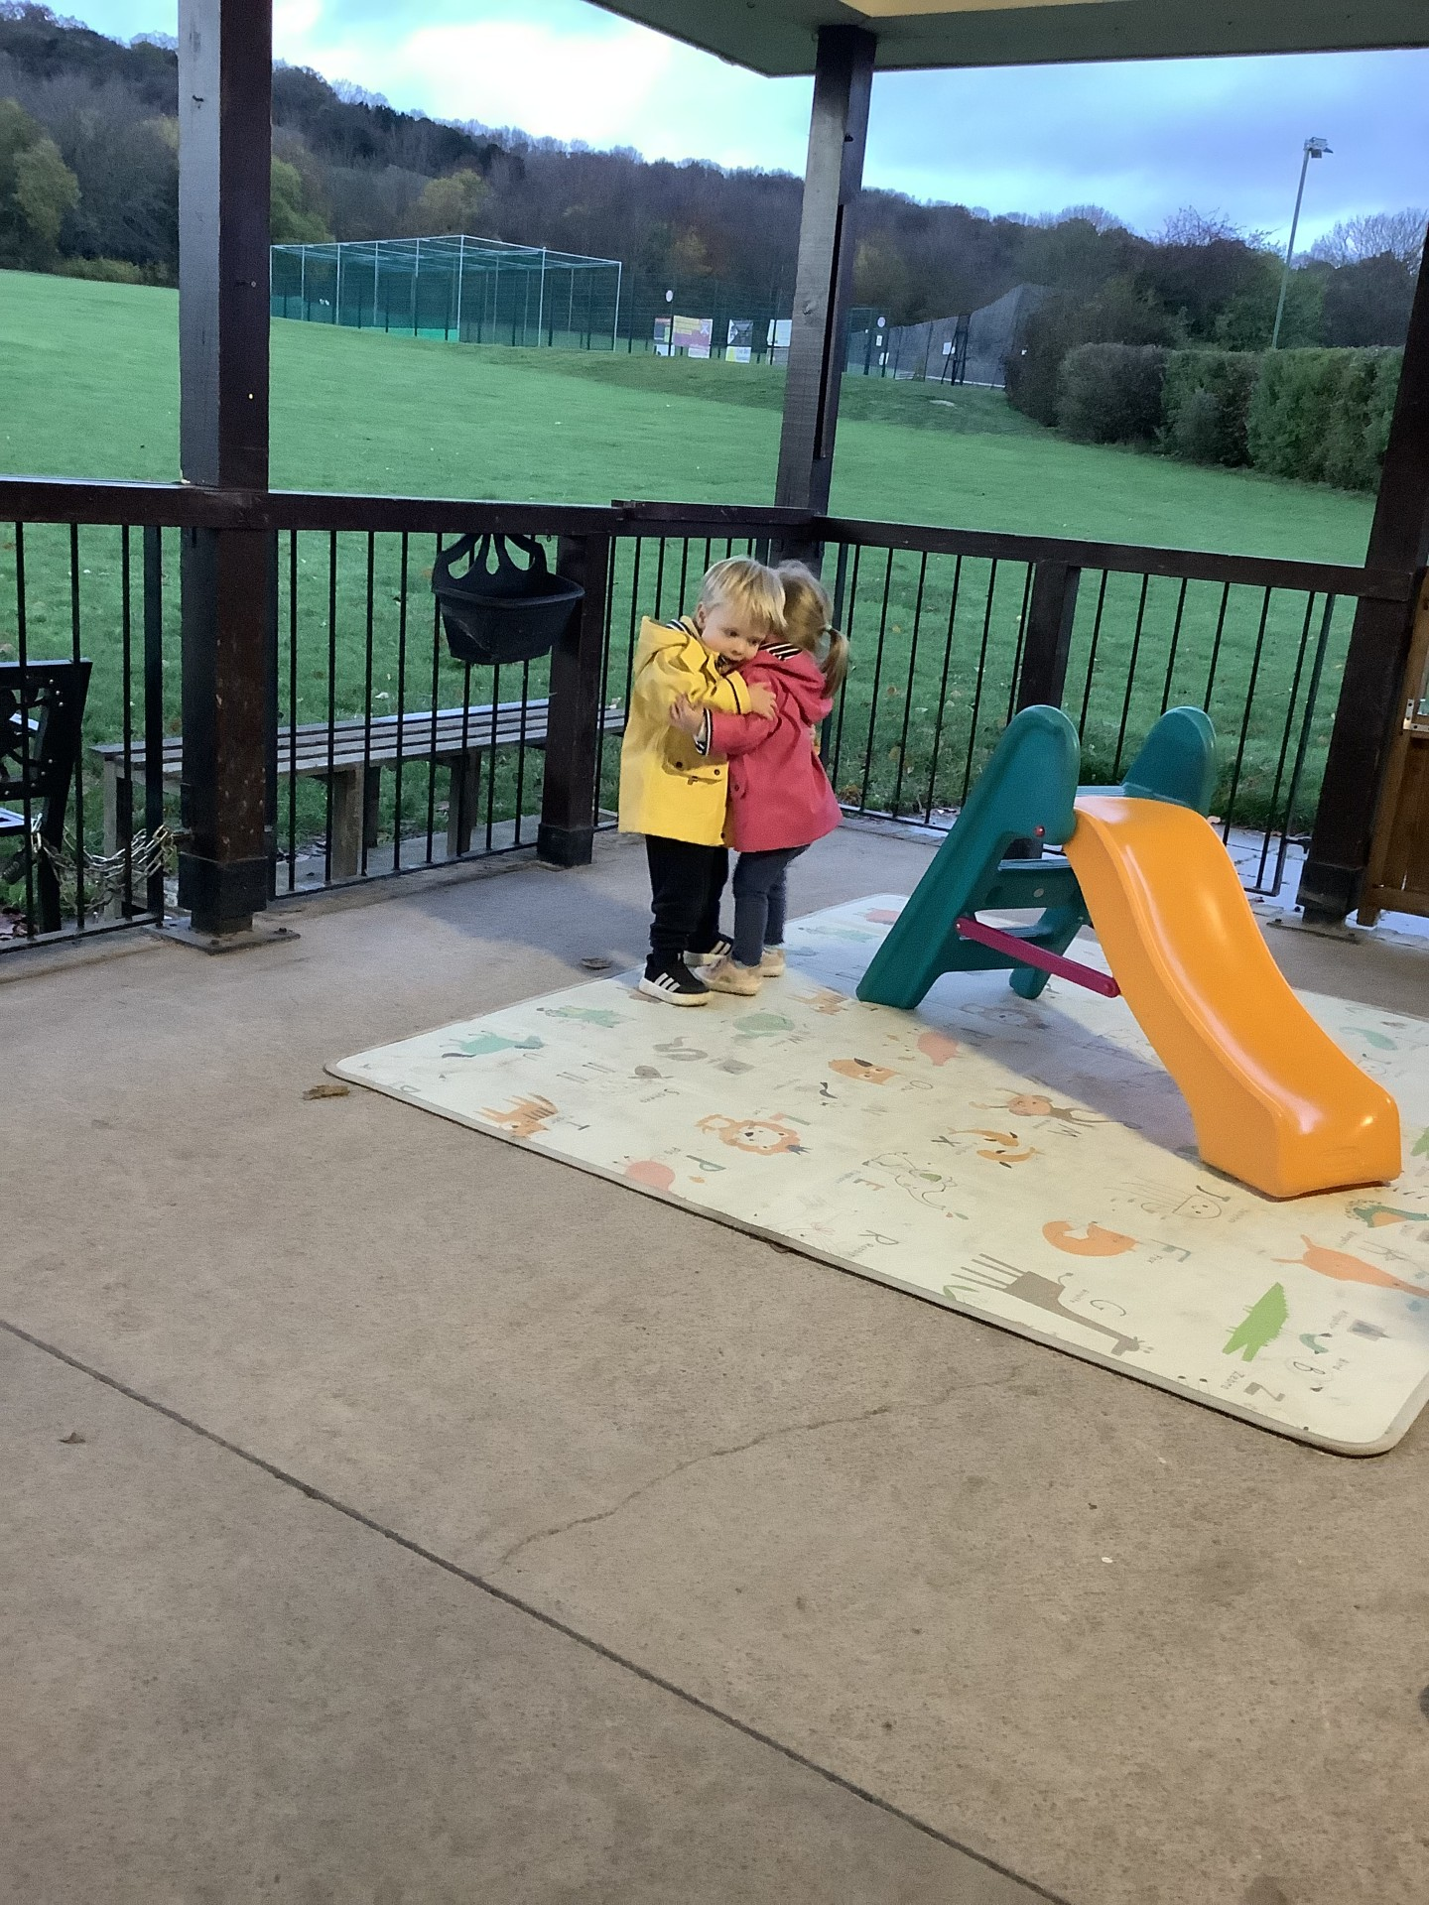

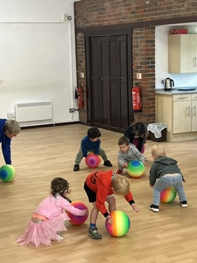
Physical Development – Children who:
develop coordination, balance and strength | move confidently
develop fine motor control | become increasingly independent with self-care
understand how to look after their bodies | develop healthy habits.

Literacy - Children who:
develop a love of books | enjoy stories, poems and rhymes
develop phonological awareness | recognise meaningful print
understand that marks and writing have meaning | develop the foundations for reading and writing.
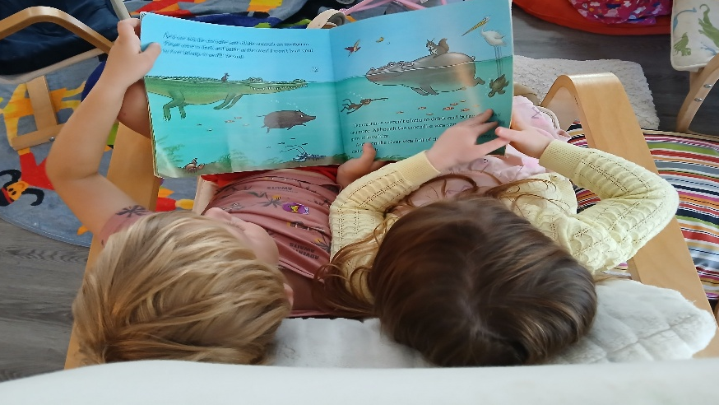

Mathematics - Children who:
develop secure understanding of number | recognise patterns
compare quantities | explore shape, space and measure
use mathematical language | apply mathematics to real-life situations
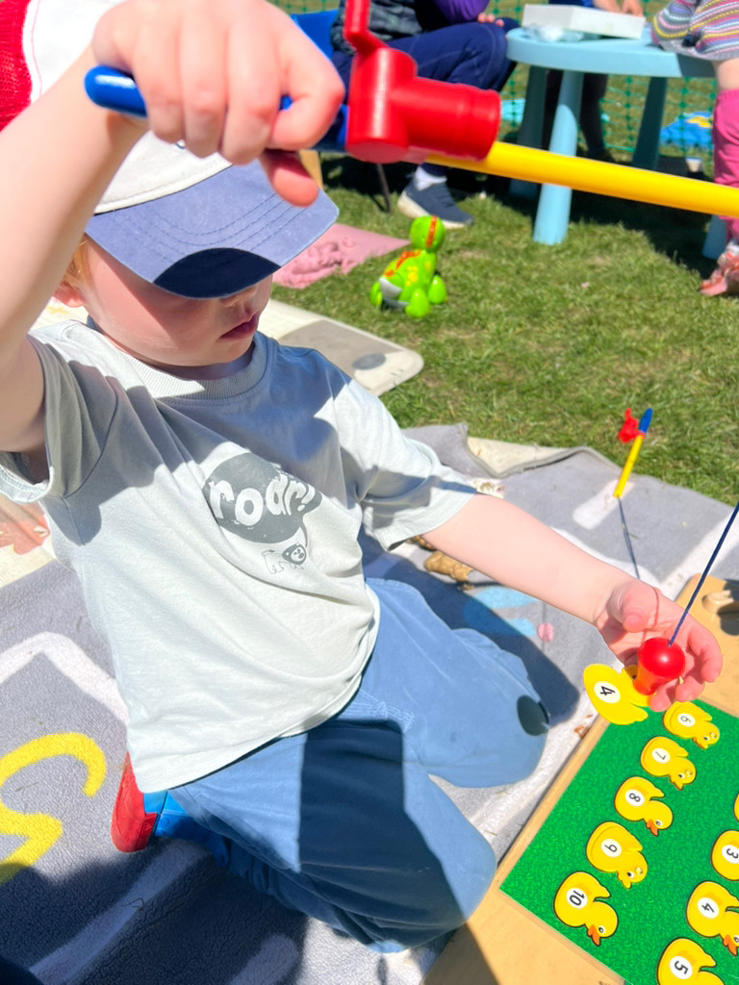

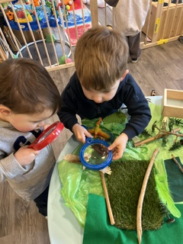
Understanding the World - Children who:
are curious about the world | understand their own families and communities
explore nature and the environment | develop an understanding of similarities and differences
investigate materials and natural phenomena | develop an awareness of people, cultures and communities beyond their own experiences.

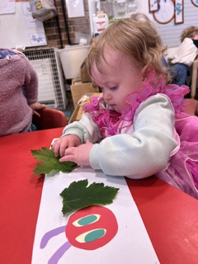
Expressive Arts and Design - Children who:
express themselves creatively | explore music, movement, art and design
develop imagination | experiment with different materials
develop confidence in performing | enjoy creating and sharing their ideas

The 7 Areas of Learning
Our curriculum covers all 7 EYFS areas:
Communication and Language Personal, Social and Emotional Development
Physical Development Literacy Mathematics Understanding the World
Expressive Arts and Design

The Bumble Bees Curriculum Threads
Instead of treating the 7 areas as seven separate subjects, we create curriculum threads that run throughout the child's time at Bumble Bees.
For example:
Communication and Vocabulary - We want children to learn:
new vocabulary | how to listen | how to take turns in conversation
how to explain ideas | how to ask questions | how to describe what they see
how to communicate feelings.

Independence - Children progressively learn:
to feed themselves | wash and dry hands | put on coats
manage shoes and belongings | use the toilet | pour drinks
tidy away | make choices | solve simple problems independently.

Relationships - Children learn:
how to form friendships | sharing and turn-taking
recognising emotions | kindness and empathy
resolving disagreements | respecting differences.

Physical Development - Children develop:
core strength | balance
climbing | running
jumping | throwing and catching
fine motor skills | pencil control
scissor skills | hand strength.

Early Reading - Children experience:
daily stories | Rhymes | songs
repeated texts | story sequencing | vocabulary
phonological awareness | environmental print | meaningful mark making.

counting | Subitising | number recognition
quantity | Comparison | patterns
shape | Space | measure
mathematical vocabulary.
Early Mathematics - Children progressively develop:
- The EYFS Statutory Framework is very clear to convey that there is no favoured method of teaching within early years. Educators will determine how best to support the learning and development of their children based around what suits their cohort and the needs of their individual children. In early years, learning can take many different forms and can look very different from setting to setting. Learning can take the form of adult-led activities, child-led learning through play-based activities, or most likely a mixture of both!

Nature and the Outdoors - Children learn through:
gardening | growing food | caring for plants
observing insects | seasonal change | mud, sand and water
weather | woodland exploration | climbing and balancing
outdoor problem-solving | caring for the environment.

Progression
Rather than: "This week we are doing dinosaurs." we ask:
What do we want children to learn?
For example:
Understanding the World – Living Things
Babies/Toddlers
Children begin to:
- Notice animals
- explore plants
- observe natural objects
- notice changes.
2–3 years
Children begin to:
- name familiar animals
- talk about plants
- notice weather and seasonal changes
- care for living things with support.
3–4 years
Children learn to:
- identify common animals and plants
- understand that plants and animals are living things
- observe changes over time
- talk about habitats
- understand basic life cycles.
Reception-ready
Children develop:
- understanding of habitats
- understanding of growth and change
- ability to make observations
- ability to compare living things
- increasingly accurate vocabulary.
That creates real curriculum progression.

The Seven Areas Become Interconnected – A Holistic Approach
Communication & Language | strawberry | seed | soil | grow
An example, an outdoor activity planting strawberries could develop:

PSED | caring for something | responsibility | patience
Physical Development | digging | carrying | pouring | fine motor skills

Literacy | reading instructions | labels | writing plant signs

Mathematics | counting seeds | comparing quantities | measuring growth
Understanding the World | plants need water/light | observing change

Expressive Arts & Design | drawing plants | creating observational paintings | songs about growing.

- This is much closer to the holistic curriculum approach than treating each area as a separate lesson.
Teaching and Pedagogy
Adults teach through:

Our Teaching goal
Curriculum → excellent teaching → children learn and develop well → strong evidence of impact.

Our "Must Know" Curriculum
By the time children leave Bumble Bees, we want them to have experienced:
hundreds of stories | shopping | learning about similarities and differences. | managing simple risks. | opportunities to speak to groups
understanding their local community | weather | Toileting and washing hands | seasonal changes | celebrations and traditions
measuring | making choices | meeting different people | pattern making | woodland experiences
counting in real-life situations | comparing | conversations with adults | visits and visitors | observing insects
growing plants | eating independently | cooking | planting seeds | songs and rhymes
new vocabulary every day. | tidying | helping others | shape hunts | caring for the environment
.

Assessment

Know - What do we want this child to learn?
Observe - What can the child currently do?
Respond - What do we need to do next?
For example:
Intent: Child develops vocabulary relating to size.
Observation: Child consistently uses "big" and "little" but does not yet use "larger", "smaller", "tall", "short".
Response: Practitioner introduces these words during block play, stories, outdoor play and everyday routines.
That is much more meaningful than simply ticking:
☐ Emerging
☐ Developing
☐ Secure

Assessment considerations – baseline, ongoing observation, professional judgement, next steps, identifying gaps.

Inclusion
All children access the same ambitious curriculum, with appropriate adaptations.
We do not lower our expectations for children because they have additional needs, are disadvantaged or have English as an additional language (EAL). Instead, we adapt our teaching, environment, communication and resources so that every child can participate and succeed.

Impact
- What children know
- What children can do
- How children behave and interact
- confidence and independence
- readiness for the next stage.

Our Curriculum Principles
We know every child well - We use what we know about each child to make appropriate decisions about teaching, support and next steps.
We prioritise communication - Children hear rich language throughout the day. Adults model, extend and introduce vocabulary in meaningful contexts.
We teach deliberately - Adults know what children are learning and use interactions, experiences and the environment to help children develop their knowledge and skills.
We value play - Play is a fundamental way in which young children explore, practise, rehearse, imagine, solve problems and make sense of the world.
We build knowledge over time - Children encounter important ideas repeatedly, with increasing complexity and challenge.
We value repetition - Children need repeated opportunities to practise and consolidate learning before moving on.
We provide real experiences - Children learn from doing, exploring, investigating and participating in meaningful experiences.
We use the outdoors as an extension of the curriculum - Our outdoor environment provides opportunities for physical development, exploration, mathematics, language, creativity, science and wellbeing.
We have high expectations for every child - We do not lower our expectations because a child has additional needs. We adapt teaching, communication, resources and the environment so that children can access the curriculum.
We prepare children for their next stage - We develop the foundations children need for future learning, rather than focusing solely on short-term outcomes.

